A History of Woodlands School
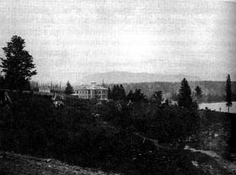
Opened May 17, 1878, as the Provincial Asylum for the Insane, housing anyone with a mental illness.

In 1897, the name was changed to the Public Hospital for the Insane.
At the turn of the century its capacity was 310 people.

In the 1930s the focus changed to housing people with developmental disabilities. Training and education began to be emphasized

In 1950 the name of the institution was changed to Woodlands School in recognition of the educational and rehabilitation emphasis.

In 1959 Woodlands School housed more than 1,400 residents

In 1962 the first Coordinator of Volunteers was hired. There were usually about 250 volunteers from all walks of life contributing their time and compassion at Woodlands.
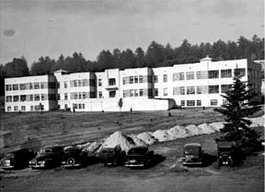
In 1974, with the transfer of Woodlands from the Ministry of Health to the Ministry of Human Resources the service delivery model shifted from medical to social. The population of Woodlands was 1,075 and its role was now described as a Community Resource Centre. There were about 1,000 staff, aided by volunteers, to provide programs to residents.

At the end of 1975 the population of Woodlands was about 1,000.
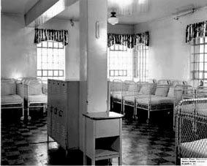
In the late 1970s and early 1980s Woodlands had approximately 1200 staff (nurses, housekeepers, dietary staff, professional social workers, psychiatrists and physicians, and persons engaged in vocational instruction) and over 800 residents (75% described as severely or profoundly retarded).

By 1980, Woodlands was only admitting people with mental disabilities whose needs could not be met in the community. Most residents at the time had multiple diagnoses such as severe behavioural problems, deafness, cerebral palsy or epilepsy.

In 1981, an estimated 100 residents out of about 830 residents were under 19 years old.
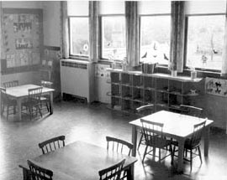
By 1987, 606 people remained at Woodlands, only nine of whom were children. Some families were reintroduced to children they had not seen in many years. This resulted in more involvement of families in the community placement process.

In the 1980s and 1990s, when the de-institutionalization program was at its peak, volunteers increased in importance to aid in community placements, travel and general liaison. Many residents placed in community settings continued to receive specialist services and outpatient care. Volunteers were pivotal to this phase.

In the 1990s the population at Woodlands began to drop sharply as the result of de-institutionalization. By January 1996 the resident count was 70.

In 1996, Woodlands closed its doors. It was the last institution to do so. (Tranquille closed in the mid-1980s and Glendale in the early 1990s).

